**Git Bash Cheat Sheet:**

Opening Git Bash:

Right click in the file directory where the repo exists and click ‘Git Bash Here’:

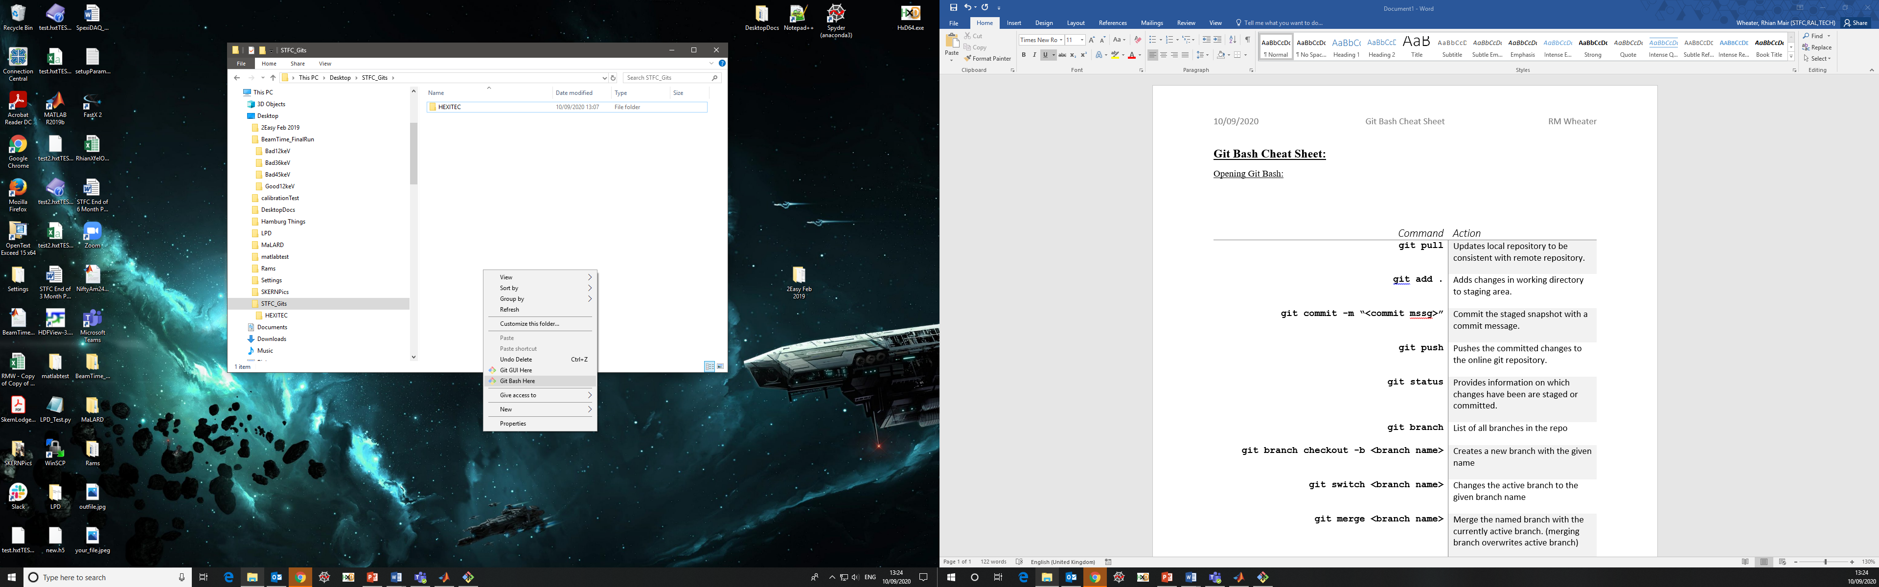

Useful Commands:

|  |  |
| --- | --- |
| Command | Action |
| **git clone <copied address>** | Creates a local version of the repository on your computer. |
| **git pull** | Updates local repository to be consistent with remote repository. |
| **git add .** | Adds all changes in working directory to staging area. |
| **git add <file name>** | Adds specific changes in working directory to staging area. |
| **git commit -m “<commit mssg>”** | Commit the staged snapshot with a commit message. |
| **git push** | Pushes the committed changes to the online git repository. |
| **git status** | Provides information on which changes staged or committed. |
| **git branch** | List of all branches in the repo |
| **git checkout -b <branch name>** | Creates a new branch with the given name |
| **git switch <branch name>** | Changes the active branch to the given branch name |
| **git merge <branch name>** | Merge the named branch with the currently active branch. (merging branch overwrites active branch) |
| **git branch –d <branch name>** | Deletes local copy of branch |
| **git push origin –delete <branch name>** | Deletes the remote branch in Git |
| **git pull origin master** | Merges the master branch with active branch |

Merging a single file from branch to master:

* Switch to master branch
* Can checkout a specific file on a branch instead of the whole branch using:

**git checkout <branch name> <file path>**

* Git status to view new changes staged for commit. Can also view the change in file manager!
* Now commit changes as normal
* Push commits

If stuck in message editor:

Press “Insert”

Type message

Press “Escape”

Type **:wq** – (for write, quit)